STATE RUSSIAN FOLKLORE CENTER SENDS THE STATE COSSACK SONG AND DANCE ENSEMBLE “STAVROPOLYE” TO JAPAN FROM 2ND AUGUST TO 14TH AUGUST 2017.

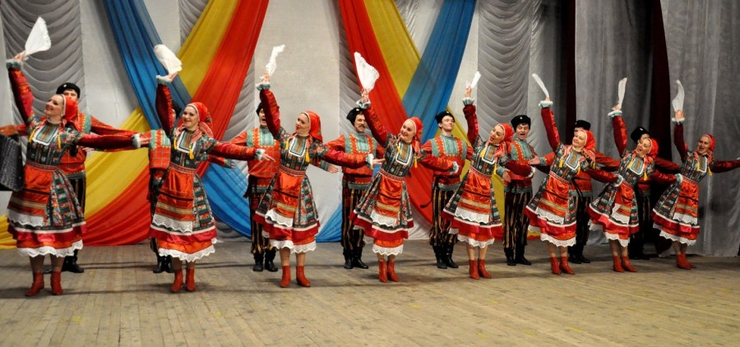
State Russian folklore center sends The State Cossack Song and Dance Ensemble “Stavropolye” to Japan from 2nd August to 14th August 2017 within the confines of the big project “Russian Seasons” in Japan.
The ensemble “Stavropolye” have been promoting traditional culture of many Cossack's peoples of Russia for more than 30 years. Its participants present this culture by different scenic compositions and songs and dances of Stavropolye, North Caucasus, Kuban and Don, Cossacks of the Central Russian Plains and Ukraine.
The founder of this ensemble is Anatolii Brunilin, a talented choreographer. His performances such as “Stavropolye's quadrille”, “Nekrasovskie vecherushki”, “Step kovylnaya”, “Cossack’s fun” attract viewers all over the world.
During many years of its creative activity the ensemble have been giving different performances on the best stages of Russia and of the whole world. Its high performing skill is marked by many diplomas, awards, medals and prizes in the sphere of music and choreography.
The ensemble is known in Russia, Ukraine, Belarus, Poland, Belgium, North Korea, Germany, France, Spain, Portugal, USA, Canada, Australia, where its performances were declared the best.
The ensemble’s director is Ivan Gromakov, the People's Artist of Russia, Honored worker of arts of Russia, winner of the RF Government Prize. The artistic director is Elena Boiko, the Honored Artist of Russia.
This year The State Cossack Song and Dance Ensemble “Stavropolye” is going to participate in the 10th World Music and Dance Festival «Kokusai Minzoku Geijutsu Sai» in Hakodate City, Hokkaido. This festival is organized in partnership with the general incorporated association “Worlds Meet Japan”.
- Ian Frank, Co-President & WMDF Festival Director
- Naoto Soga, Co-President & WMDF Artistic Director
- Takuma Fukuda, Secretariat
- Motoaki "Kitt" Kitamura, Inspector

Organizers of the festival did not accidentally chose Hakodate as the festival’s place. Celebrating its tenth anniversary in 2017, WMDF has already hosted over 1,750 artists from 46 different countries and regions. Festival stages have superb ocean bay views. Hakodate's population of 300,000 gives it a friendly, small-town feel. It is a major destination for Japanese travelers, who come to see the famous view from the top of Hakodate Mountain, and to try some of the best seafood in the country. More than 4.5 million tourists visit the city every year.
Staged on the northern island of Hokkaido amid the world architecture of the old town area of the city of Hakodate, this week-long event features four stages and six different festival areas. Hakodate’s citizens and tourists try not to miss any concert, and more than 30000 viewers will see the concert. Besides, there are many different creation meetings, handmade lessons, visual arts, street performances during festivals days. Organizers are waiting for “Stavropolye”’s performances on in the 10th World Music and Dance Festival with great impatience.

